**Investment banking:** An **investment bank** is a financial institution that deals in stocks and bonds for corporations and provides other financial services, such as assistance with mergers and acquisitions, pension fund management, financial sponsorship, and payment solutions.

**Stock:**

* A stock is a security that represents a fractional ownership in a company.
* When you buy a company's stock, you're purchasing a small piece of that company, called a share.

**Share:**

* A share represents a unit of equity ownership in a company.
* Total Capital market is divided into equal unit and each unit is called as Share.
* **There are two type of Share in Market:**
* **Common Share:** Common stock is a class of stock that represents equity ownership in a corporation.
* **Preferred Share**: Preferred stock is a type of stock that pays shareholders a specified dividend and has priority over common stock for receiving dividends

|  |  |
| --- | --- |
| **Common Share** | **Preferred Share** |
| Common Stock holders have lesser claim on the distribution/dividend than Preferred Stock holder | Preferred stock holders have higher claim on the distribution/dividend than common stock holder |
| Common stock holders have the voting rights. | Preferred stock holders do have the voting rights. |
| Common shareholders have less priority over a company's income, meaning they are paid dividends after Preferred shareholders. | Preferred shareholders have priority over a company's income, meaning they are paid dividends before common shareholders. |
| When a corporation goes bankrupt P.S. holder receive their money first. Then Common Share holder gets money. | When a corporation goes bankrupt P.S. holder receive their money first. |
| Common Share holder have high risk than Preferred Share holder. | Preferred Share holder have lesser risk than Common Share Holder. |
| Common stock holder margins not available to purchase for stock | Preferred stock holder margins is available to purchase for stock |

**There are two type of Order in Market:**

* **CNC (Cash in Carry) Or Delivery or long term:** CNC is an abbreviation for Cash and Carry. It is an order type used for delivery-based orders. If you want to buy a stock and want to hold it for more than two days, then you need to use the CNC order type.
* **MIS/ Intraday : Margin intraday Square off:**MIS is Margin Intraday Square Up. These orders are purely intraday orders and need to be squared off during the same trading day. Now intraday is not just the buying part, it also includes the selling part. It not only includes buy and sell but you can also sell and buy the same day.

|  |  |
| --- | --- |
| **CNC** | **MIS or Intraday** |
| If we have to hold share more than 2 day. | We have hold share for 1 day or trading only |
| Margin is not available | Margin is available |
| CNC as 1st buy and then sell. | We have 2 option as : 1st buy and then sell and 1st sell and then buy |
| It is long term | It is for short period or one day only |

**Types of Orders:**

* **Market order:**
* In the regular Intraday as well as for long-term market order, we can buy share at market price only. **We cannot quote any price for the share.**
* **For Buy:** here we have filled only one field then click on buy order will be placed in order tab. Here we cannot quote the price of stock.
* **For Sell:** we have filled only one field then click on buy order will be placed in order tab.
* **Limit Order:**
  + In the regular Intraday as well as for long-term limit order we can buy the share at our preferred price. That means if the share touch the price that we have quoted, the order will get executed.
  + **For buy:** The price we have to define when the limit price is matched with seller then NSE will execute our orders and settled it.
  + Here we have to fill the 2 fields as quantities , limit price and then click on buy , order will settled by application and send request to the NSE.
  + **For Sell:** The price we have to define). When the limit price is matched with buyer then NSE will execute our orders and settled it.
  + Here we have to fill the 2 fields as quantities , limit price and then click on buy , order will settled by application and send request to the NSE.
* **Stop loss order:**
  + In the regular Intraday as well as for long-term Stop loss order, we can buy the share at our preferred price and we can also provide Trigger price to minimize the loss.
  + Here we have fill 3 fields as quantity, limit price and triggered price.
  + **For buy** with Stop loss order limit price or prefeered price is always greater triggered price.
  + When the trigger price or limit price is match with market price of share then our order we executed with limit price that we have set.
  + **For Sell** with Stop loss order triggered price is always greater limit price or prefeered price.
  + When the trigger price or limit price is match with market price of share then our order we executed with limit price that we have set.
* **Stop loss at Market price order:**
  + In the regular Intraday as well as for long-term Stop loss at market Price order, we can buy the share at market price and we have to provide Trigger price to minimize the loss.
  + **Stop loss at Market price order for buy:**
  + For applying stop loss market price order we have to fill 2 field as quantity and triggered price.
  + Here when our triggered price is match with market price of stock then the order will place as with Market price or current price of stock that we have to buy.
  + **Stop loss at Market price order for Sell:**
  + For applying stop loss market price order we have to fill 2 field as quantity and triggered price.
  + Here when our triggered price is match with market price of stock then the order will place as with Market price or current price of stock that we have to sell.
* **Technical Flow:**
* If any investor wants to increase their capital then they start trading through IB.But they cannot do directly start the trading.
* For trading they need to open a trading account. So for opening account investor need a brokerage company.
* By using the application they will open an account and will get ID and password. After getting ID and password they will add the fund into trading account.
* The investor has to select the type of trading account like equity etc.After successful login investor will start the trading.
* Now our application **FxPro** is connected with **London Stock Exchange** which gives details about stock price and market value to the IB.
* Then investor is search for share in Watch list and add then order is initialize in the application it shows in order tab as order management system.
* There is concept of buyer and seller when seller sales some stock then buyer should be available to buy that share at a time.
* Stock exchange will do matching of share or stock.When buy and sell will match then BSE will executes orders.
* **Settlement and Clearing:** At the end of the day when stock market closes, settlement of security and cash between investment bank and stock exchange takes place.

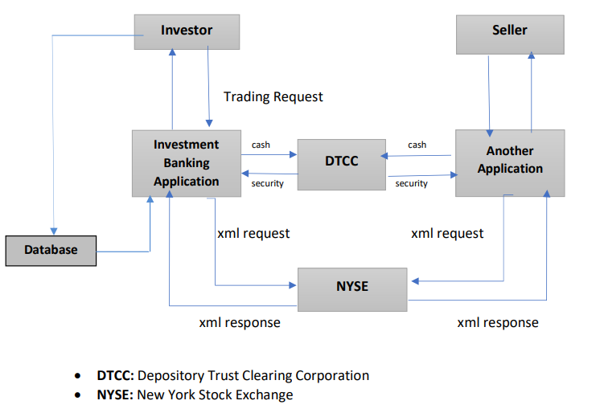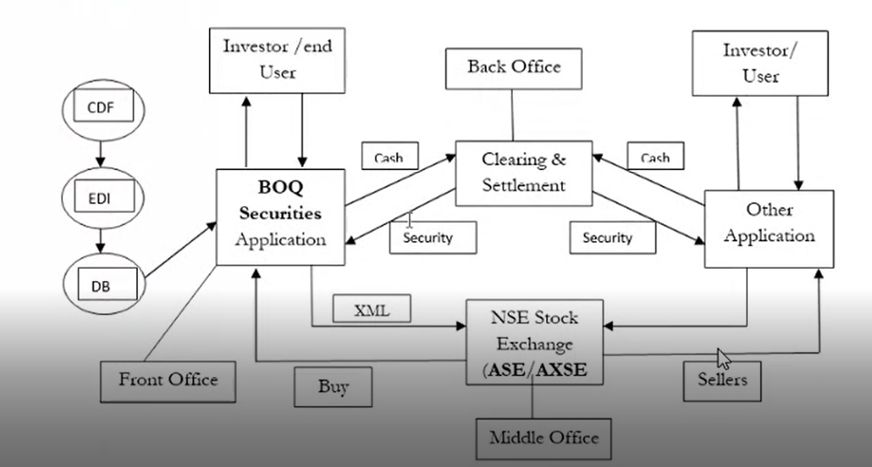

* **Business Flow As:**
* Function- Buy and sell the stock.
* When big investor wants to increase their capital and if they don’t have knowledge of trading then they will approach to the IB.
* Investor will use the application and IB will get brokerage.IB also work as a consultant and will get consultant fees.
* IB also suggests for merging of two companies and provides all records and get the brokerage charge.
* IB also provides details to company if that company want to take over another company.
* IB also helps for IPO. IB will give suggestion to buy the IPO of good companies.
* **Trading Life Cycle:**
* Through FxPro Application investor invest in Share/ Stock, derivatives, commodities and mutual funds.
* **Share :**
* Trade CFDs on thousands of global shares and benefit from ultra-fast order execution and competitive trading conditions. Trade CFDs on shares of some of the largest and most popular companies in the US, UK, and EU.
* **Derivatives:**
* **Forex trading – Currency exchange trading:**
  + The most popular FX pairs involve major global currencies and experience the highest trading volumes and liquidity.
* **Commodities:**
* **Futures** trading:
  + Futures are a popular investment method for many traders as it allows the speculation on the value of a range of commodities, indices and energy.
  + Trade CFDs on Futures from around the world and explore endless trading opportunities such as cotton, wheat ,coffee,sugar, oil and gas.
* **metals** trading:
  + Trade CFDs on Spot Metals and unmask new trading opportunities such as Palladium, platinum, gold, silver, aluminium, copper etc.
* Trade CFDs on **Energy:**
* Trade CFDs on Spot Energy such as Brent oil, WTI and Natural Gas and diversify your portfolio.
* **Mutual Funds:**
* Spot **indices** trading:
  + Trade CFDs on popular Indices from across Europe, Asia and America.
  + The most popular indices are those that combine the shares of some of the largest and globally acknowledged companies.
* **Trading life Cycle as some Steps:**
* Order indication.
* Order management
* Trade execution
* Clearing
* Settlement.
* **Order Indication: (Front Office)**
* In FxPro Application, investor search stock from watch list then share added. Then order will place in order indication.

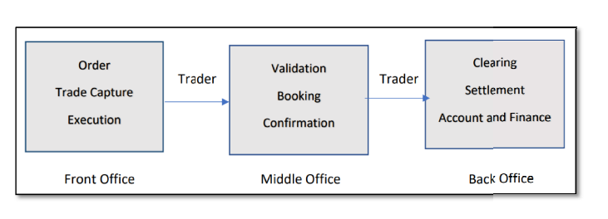

* **Order Management: (Front Office)**
* Investor or end user placed order is shown in orders tab as order management system
* **Order has different Status:**
* **Open/ Pending** : Share close / seller not available/ share market server issue
* **Execute or trade :** buyer and seller matches (Order type & Price)
* **Cancelled or rejected :** investors can cancel the order (Cancel reason amount insufficient , investor cancel)
* **Trade Execution (Middle office):**
* Trading executed when buyer and seller has been matches (Quantity, Price) then Execution is done by LSE.
* **Clearing and Settlement (Back office)-**
* After market close whatever trade has execute clear securities and cash settlement.
* T= Trade execution (Order buy or sell)
* T+1 = Clearing and settlement.
* T+2= in bank account we will get all money.

**Front Office:** Orders are received from investors and when the order type and price of the share is matched with the seller, at that time order gets executed.

**Middle Office**: At the end of the day confirmation mails are sent to the client which includes transaction record of client with details of trades.

**Back Office**: After-market is closed clearing and settlement is done in T+2 Days. This also maintains account and finance.

**Different Types of Testing performed:**

* **Functional Testing Coverages:**
* Behavioural Coverage
* Input Domain Coverage (Boundary value analysis)
* Error Handling Coverage
* Backend Coverage
* Calculation Based Coverage
* Service level Coverage
* **Non-Functional Testing Coverages:**
* Compatibility Testing
* Intersystem Testing
* Recovery Testing
* **Regression Testing**
* **Sanity Testing**
* **Basic core functionality Validation:**
* Here we check main flow of application from start to end or page to page i.e. We check happy flow.

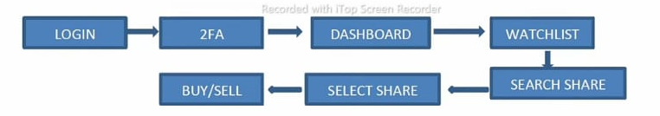

* **Input Domain coverage testing.**
* Checking what is size or length of object and type of object (i.e. data type) or validation data types of input size and length of input.
* **Error Handling Coverage:**
* In this testing we check when we enter invalid data or blank data in the object then the system is displaying or showing error message or not.
* **Backend coverage testing or Database Testing:**
* Validating all front end operations are stored in database.
* **TAB Validation :**
* We check functionality of tab , where we enter character’s , numbers , symbols and we check whether this text box is accepting it or not.
* **Graphical User Interface or GUI Validation:**
* Here we validate the GUI of application based on SRS document or provided screenshot in user story.
* **Page Validation:**
* We check, can we navigate from one page to other page.
* **Link Validation:**
* In this validation, sequence of interlink pages are tested.

### Testing the Database of an Investment Banking application:

* Login to the IB application and create a profile for a Client with all required mandatory details and save the details. Now login to the database of the same IB application and verify the details of the client through SQL queries. All the details entered through the front-end application needs to be saved in the database.
* Open an existing record of a Client and modify few details like email, address or phone number and save the data. The updated details should get saved in the database.
* While creating a profile for a Client, enter only a few details and without saving the data close the application or sign out from the application. Now check in the database that the earlier entered details should not get saved.
* Try to create a duplicate record for an already existing client, the record should not get created.
* On behalf of a Client place 2 or 3 trade orders and submit. Now verify the database whether the same trade orders got updated in the database or not.
* Login to a Client’s account and cancel an existing order, now check the same in the database that the particular record should get canceled.

### Testing the Security of an Investment Banking application:

* Create a Client’s profile, enter the username or login id and enter the password too. The data in the password field should be encrypted so that the hackers cannot find the password.
* Try to login to the application with invalid credentials. The system should not allow the login.
* While navigating through the pages in the IB application or website the back button functionality of the browser should not work. (Mainly for financial websites this functionality should be blocked.)
* Login to the application and try to perform any transaction and leave the system idle for some time. Then try to proceed with the transaction the system should get logged off. This indicates the session time-out of the application.
* Try to login to the application with for a particular user Id with an invalid password and repeat the same for 3 attempts. Then the particular login id should be blocked. This feature restricts hackers from entering into the system with bulk data.
* Login to the application and perform any transaction. And now verify the cookies of the browser, they should be in an encrypted form to avoid hacking of the data.
* **Testing the *Performance* of an Investment Banking application:**
* While navigating through the IB web-site check whether the system responds quickly to an action performed or not. This determines the speed of the application.
* Try to login to the IB application with various user Ids simultaneously from various systems (no. of users that the application can handle). The application should handle multiple user logins the way it is intended to.
* Login to IB site with a user Id and place the huge number of trades included with some complex funds transactions. This reveals the ability of the application to handle large volume.
* Login to IB site with various user Ids from various systems parallel and perform huge transactions from all the used Ids at the same time. This shows how much stress the application can handle.

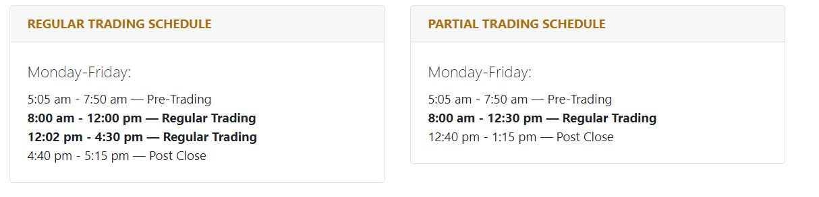

**Test Scenarios:**

**Positive Scenarios:**

* The Investment banking applications have different logins for different users like brokers, dealers, individuals or investors etc.
* **Verify the logins of appropriate users with their login IDs as the permissions for accessing the application for all the users may not be the same**.
* **For example**, a broker has permission to view the trading limits of the individuals based on the funds available in the individual’s account. However, this facility may not be available for the individual.
* The function of the Watch-list can be verified by adding, removing the securities/symbols to it. Ensure that the removed symbols should get deleted from the Watch-list and vice versa.
* **Buy Order –** To test this functionality, place a trade buy order for any symbol with some quantity like 10 or 20 etc. and submit the same. Then go the orders section and verify the details whether the order has been placed successfully or not.
* **Sell Order –** Place a trade sell order as above (buy order) and verify the details.
  + **Change Order –** Go to the orders section and open any previous order or existing order and make few changes like editing the quantity or symbol etc. and verify whether the modifications get updated or not.
  + **Cancel Order –** Open an existing order and try to cancel it. The order should be canceled successfully.
* **Different types of orders have to be tested.**
* **Market order –** Try to place a trade order for the market price and check whether the trade gets executed for that price at the same point of time.
* **Limit order –** Try to place an order for a particular price and check whether the trade has been executed when the market price meets the price set by the user.
* **Stop loss order:** In the regular Intraday as well as for long-term Stop loss order, we can buy the share at our preferred price and we can also provide Trigger price to minimize the loss.
* **Stop loss at Market price order:** In the regular Intraday as well as for long-term Stop loss at market Price order, we can buy the share at market price and we have to provide Trigger price to minimize the loss.
* Check and verify whether the proper notifications or warning messages are getting displayed for the corresponding actions.
* **For example**, after placing a trade buy order and submitting it, a message should be displayed that the ‘order has been placed successfully’.
* Try to update the user information like email, mobile no. etc., save it and log out from the application. Login to the application and verify whether the updated information has been saved or not.
* Test the calculations part of the application very thoroughly and also, test its localization.
* The security of the application should also be tested as it contains the personal data of the users.
* Applications quality, look and feel, user friendliness etc. are also to be tested as it gains the user’s trust.

**Negative Scenarios:**

* Try to place a trade order for more than the value of funds available in the account and the order should not get placed and it should pop-up a warning message stating that the funds are insufficient.
* Test the ‘quantity of shares’ feature in the application. Place a trade order for the number of shares greater than the available quantity of shares. Trade should not be placed as the quantity of shares requested is more than the available quantity.
* Try to place a trade order for a stock for which the expiry date has been reached. The order should not get placed.
* **Some of the defects I found during testing of the application:**
* View Statement link on dashboard is not working.
* On dashboard in holding section radio buttons are working, but data is not reflecting on chart properly.
* In the Watch list section, the stock price fluctuation is not happening.
* The user is not able to rename the watch list.
* On Holdings tab quantity of shares is not showing properly.
* On a Holdings tab, after clicking on Authorization, the user is not able to redirect to the Authorization page.
* The user is not able to exit from position in intraday order.
* In a Watch list search section, the user is not able to search the stock.
* The user is not able to withdraw funds from trading account.
* When the user is placing an intraday limit order, at that time Trigger Price textbox is also enabled.
* When the user is trying to change the order type from buy to sell using the toggle button provided it is not working.
* In funds tab, ‘Help’ link is not working as expected.
* Total count of stocks which are in watch list are not showing properly.
* When the user deletes the particular stock from the watch list, it is still showing in the watch list after deleting.
* There is a spelling mistake in Add Funds Tab.
* If investor is search share in watch list of one company but system or application shows shares information of another company.
* When I click on buy it shows sell window.
* When I click on buy it shows sell window.
* I got defect that when I place order after market closed and it is placed.
* Help tab functionality is not working so button is not clickable.
* **Some Scenarios :**
* Verify that market order tab for buy in CNC for buy expected result as only quantity field is enabled and end user can place the order.
* Verify that market order tab for buy in Intraday when market opens or trading day expected result as only quantity field is enabled and end user can place the order
* Verify that market order tab for buy in Intraday when market close expected result as it shows Warning message as “Intraday will open again at 9.15 am on the next trading day”.
* Verify that market order tab for buy in Intraday when market open/close when quantity field is blank and user tries to place order expected result as it should shows Warning message as “All input are required”. And buy button get disabled.
* Verify that market order tab for buy in Intraday when market open/close when we enter in quantity field as min value of 0 or 0.0 or 1.30 and user tries to place order expected result as it should shows Warning message as “min share you can buy is 1”. And buy button get disabled.
* Verify that market order tab for buy in Intraday when market open/close when we enter in quantity field as max value of 10000000000and user tries to place order expected result as it should shows Warning message as “enter quantity between 1 to 20000”. And buy button get disabled.
* Verify that market order tab for buy in Intraday when market open/close when we enter in quantity field as negative value of “-1000”and user tries to place order expected result as negative values is not accepted.
* Verify that market order tab for buy in Intraday when market open/close when we enter in quantity field as character or special symbols of “%#cab” and user tries to place order expected result as character or symbol is not accepted.
* Verify that market order tab for buy in delivery when market close expected result as user can place the order but it should be in open state
* Verify that market order tab for buy in delivery when market opens expected result as user can place the order but it should be placed it will be executed.
* Verify that market order tab for Sell in Intraday when market opens or trading day expected result as order should be placed.
* Verify that market order tab for Sell in Intraday when market close or trading day expected result as
* Verify that market order tab for Sell in Delivery when market opens or trading day expected result as order should not be placed.
* Verify that market order tab for Sell in delivery when market close expected result as order should not be placed.
* Verify that market order tab for Sell in Intraday when market open/close when we enter in quantity field as character or special symbols of “%#cab” and user tries to place order expected result as it will shows warning msg to user
* Verify that market order tab for Sell in Delivery when market open/close when we enter in quantity field as character or special symbols of “%#cab” and user tries to place order expected result as it will shows warning msg to user
* Verify that market order tab for Sell in Intraday when market open/close when we enter in quantity field as min value of 0 or 0.0 or 1.30 and user tries to place order expected result as it will shows warning msg to user
* Verify that market order tab for Sell in Delivery when market open/close when we enter in quantity field as min value of 0 or 0.0 or 1.30 and user tries to place order expected result as it will shows warning msg to user

**Project Name: Equity Share Trading System**

**Client:** **FxPro, UK**

**Domain: Investment Banking**

**Description**

FxPro UK Limited is authorized and regulated by the FCA since 2010. FxPro Financial Services Limited is authorized and regulated by the CySEC since 2007 and by the FSCA since 2015. FxPro Global Markets Limited is authorized and regulated by the SCB. FxPro offers Contracts for Difference (CFDs) on 6 asset classes: Forex, Shares, Spot Indices, Futures, Spot Metals and Spot Energies. We provide our clients with access to top-tier liquidity and advanced trade execution with no dealing desk intervention.

* + - Client Name : FxFro UK Limited.
    - FCA : Financial Conduct Authority.
    - CySEC : Cyprus Securities and Exchange Commission.
    - FSCA:The **Financial Sector Conduct Authority** (FSCA) is responsible for market conduct regulation and supervision
    - SCB : **Standard Chartered Bank**.
* **Derivatives:**
* A derivative is a financial contract that derives or calculate the value from an underlying asset.
* It is a financial contract between 2 parties as buyer and sellers within specific time and price.
* The four major types of derivative contracts are **options, forwards, futures and swaps**.
* **Future:** It is contract between two party’s buyer and sellers for asset for buy or sell at a certain price and certain time.
  + Whenever we have to purchase future we have buy in lots or bundles.
  + Future derivative is mandatory we have hold for 1 month .Then it will sold automatically at last Thursday of month.
  + **Option:** It is contract between two party’s buyer and sellers for asset for buy or sell at a certain price and certain time.
  + Whenever we have to purchase future we have buy in lots or bundles.
  + Options derivative is not mandatory we have hold for 1 month .Here we have right to sell the derivative when we see the Profit.
  + **Options have 2 types:**
* Put: A buyer have right to sell the asset, with a certain time and with a certain price.
* Call: A buyer have right to Buy the asset, with a certain time and with a certain price.
* **Forward:** It is financial contract between buyer and seller but hand to hand (Oral Communication)
* **It is not secure. So not in use by Application because they require some kind of proof.**
* **Swap:** It is financial contract between buyer and seller but hand to hand (Oral Communication) for changing their interest rate.
* It is not secure. So not in use by Application because they require some kind of proof.
* **Commodity:**
* It is financial contract between buyer and seller for natural product.

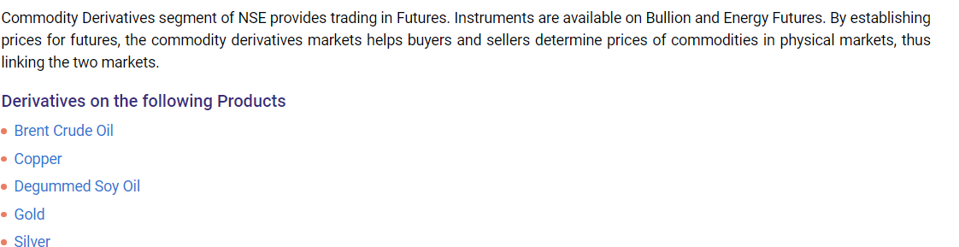

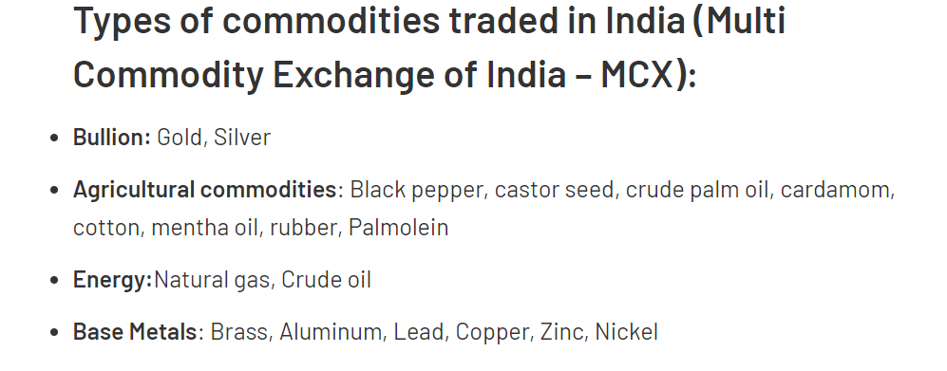

* For trading with commodity we require special Trading account. We have to send special request to NSE.We have purchase derivative in terms of in terms of lots
* **IPO (Initial Public Offering):**
* **IPO (Initial Public Offering):** When unlisted company (A company which is not listed on the stock exchange) announces initial public offering (IPO) when it decides to raise funds through sale of securities or shares for the first time to the public. In other words, IPO is the selling of securities to the public in the primary market.
* It is open for only 2 days
* Company has to provide asset value to NSE
* We have to purchase IPO in lots only means quantities are fixed with fixed price.
* After Completion of IPO or 2 days then it converted into Normal Stock.
* **Mutual Funds**
* When investor want to invest their capital in Share Market but they don’t have any trading knowledge so they will approach towards mutual Funds to increase their capital or get the revenue.
* Mutual funds are operated by professional money managers, who allocate the fund's assets and attempt to produce capital gains or income for the fund's investors.
* Mutual funds invest in a vast number of securities, and performance is usually tracked as the change in the total market capital of the fund—derived by the aggregating performance of the underlying investments.
* Mutual funds charge annual fees (called expense ratios) and, in some cases, commissions, which can affect their overall returns.
* Investor invest money in multiple companies through fund manager of mutual fund and get the revenue
* **Types of Mutual Funds:**
* **One time Investment :** Here we done investment in one time**.**
* **SIP (Systematic Investment Plan)** : Here we invest money in mutual funds based on monthly basis. The selected amount will be deduct by system on monthly basis
* **Bonds:**
* Whenever any company have to raise money through market they raised money through the dept. instrument.
* Dept. instrument is nothing but the asset of the company. So bond is nothing but dept. instrument created for raising the money or capital.
* Bond it is loan agreement between company and investor for specific time and specific price based on interest rates.
* **3 types of Bonds:**
* **Corporate Bond:** This bond is released or issue by corporate company. Interest rate is more in corporate bonds. It has very high risk.
* **Government Bond:** This bond is released or issue by Government Body. Interest rate is less as compare to corporate bonds. But it has very low risk.
* **Municipal Bond (Financial Institute):** This bond is released or issue by Municipal Corporation. Interest rate is more in corporate bonds. It has very high risk.
* **Demat account:**
* Demat Account is an account that is used to hold shares and securities in electronic format. The full form of Demat account is a dematerialized account.
* The purpose of opening a Demat account is to hold shares which we have bought are dematerialized (i.e. converted from physical to electronic shares).
* Thus, this makes share trading easy for the users during online trading. So, Dematerialization is the process of converting the physical share certificates into electronic form, which is easier to maintain as well as accessible from anywhere throughout the world.

**Telecom Domain**

* **Introduction:**
* Sending voice, data, picture, fax, etc., from one point to another using electronic media is termed as telecommunication and in short it terms as **telecom**.
* Examples include Phone, Radio, Television and Internet.
* **Parts of Telecom Domain:**
* **Business Support System (BSS)** : This domain takes care of all the needs of customer. That is, it is responsible for generation of bills, fulfilling additional requirements, addressing each of the customer queries, providing value added services to the end user etc.(# We work under BSS Domain)
* **Operational Support System (OSS):** This domain works on activating and deactivating the services for customers. Restoring the services etc.
* **How Do The Telecom Services Generate Revenue?**
* **Business Flow(the ways of revenue generation for service provider):**
* Telecom operators charge their customers in multiple ways, some of the ways are listed below:
* **One Time Charge:** Charged once at the time of connection.
* Rental Charges: These are the charges taken from the customers on monthly basis against a service provided. For example, your telephone monthly charges would be Rs 499 regardless you use it or not.
* **Value added service Charge:** If any extra services are subscribed, then these charges are charged.
* **Usage charge:** Depending upon the use of services these charges are taken
* **Roaming charge**
* **Service Tax**
* **Documentation Charge**
* **SMS Charge**
* **Different Ways of Billing:**
* **Pre-pay Billing:** where customer pays in advance and after that starts using a service. Usually, prepaid customers do not receive any invoice and they are charged in real time.
* **Post pay Billing:** Here, customers buy products and services and use them throughout the month, and by end of the month, invoices are generated by the service provider and sent those invoices to the customers to make their due payment.
* **Interconnect Billing:** The network operator is usually financially responsible for services provided to its customers by other networks regardless of whether or not the customer pays for the service.
* **Roaming Charges:** When a customer goes from one network operator's coverage area to another operator's coverage area, first operator would pay marginal charges to second operator to provide services to their customers. Such type of charges are settled through roaming billing.
* **Convergent Billing:** Convergent billing is the integration of all service charges onto a single customer invoice.
* **Billing Systems:**

Keeping track of all the billings and services would be very difficult manually, so a billing system is used which provides flexibility to both the service providers and customers.

* **Features Of billing Systems:**
* **Rating & billing:** This involves rating the products or services usage and producing monthly bills.
* **Payment processing:** This involves posting of the customer payments to customer's account.
* **Credit control and collections:** This involves chasing the outstanding payments and taking appropriate actions to get the payments.
* **Disputes and adjustments:** This involves recording any customer disputes against their bills and creating adjustments to refund the disputed amount in order to settle the disputes.
* **Pre-pay and post-pay services:** This involves supporting both pre-paid and post-paid customer base.
* **Multilingual & multiple currencies:** Multilingual and multiple currencies support is required if the business is spread across the globe and have multinational customers.
* **Inter-carrier settlements:** This involves sharing of revenue between carriers that provide services to each other's customers.
* **Products & services:** This involves providing flexible way to maintain various products and services and sell them individually or in packages.
* **Discount applications:** This involves defining various discount schemes in order to reduce customer churn and attract and increase customer base.
* **Now how exactly the billing system works? (Technical Flow)**
  + The billing System which we use is **CRM- Customer Relationship Management.**
  + **OMOF:** Order Management Order Fulfillment
  + Examples: Salesforce CRM, Siebel CRM
  + And we are making use of Siebel CRM

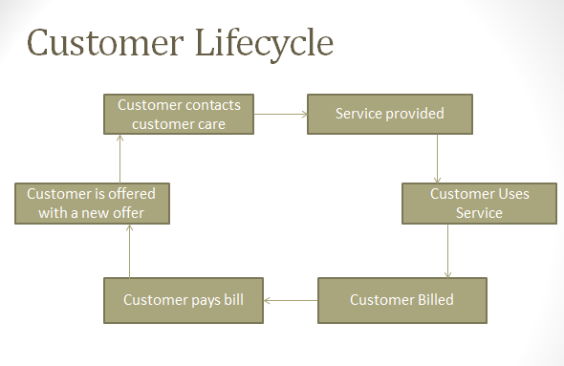

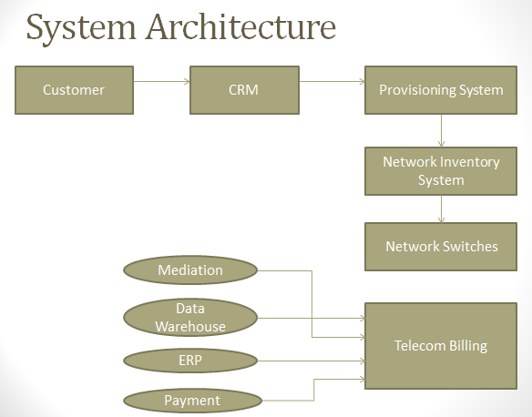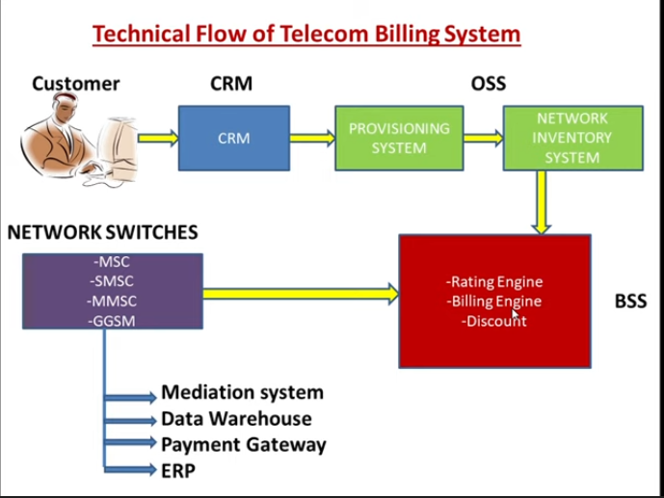

**BSS-Business Support System.**

**Rating engine-**It is part of BSS.It decide charge or rate for particular service. Whatever charge according to service is apply by rating engine. According to the received CDRs from the mediation system. It assign the charge.

**Billing engine-**It produces the raw data to generate final invoice .It includes customer details, service details, charge according to the plan produced by billing engine.

**Discount –** Whatever the discount provided by company is also calculate here and according generate bill

**Network switches Elements:**

* **MSC-** Mobile switching center –
* **SMSC-**Short msg service center
* **MMSC**-Multimedia media service center
* **GGSM-**GPRS gateway service node

**Network switches Elements:**

* Mediation system
* Data WareHouse
* Payment Gateway
* ERP

**CRM/OMOF:**

* This is the first system from where a customer order is captured and customer is created into the system.
* The CRM/OMOF (order management order Fulfilment) system keeps customer related information along with product and services.
* **What does CRM do?**
* Actively tracks and manages customer information.
* Connects your entire team from any device.
* Intelligently captures customer emails.
* Simplifies repetitive tasks so you can concentrate on leads.
* Delivers instant insights and recommendations.
* Extends and customizes as your business grows.
* **Why CRM matters?**
* CRM helps you ditch clunky processes and manual effort so you can get on with business.
* You’ll find more leads, close more deals, keep more customers and grow your business.
* One place to store all customer information means your conversations are always personal, relevant, and up to date.
* **Provisioning System:**
* Here the customer request will get segregated according to the core domain and then it will be transferred to a particular domain where it belongs.
* After taking provisioning commands, this system contacts with core network system to activate, deactivate or suspend the services.
* **Network Inventory System:**
* This system maintains all the network identifiers like phone numbers, MSISDN, IP addresses, e-mail, addresses, etc., and technically it is called Network Inventory System.
* This system is responsible to maintain the life cycle of network identifiers.
* **Network Switches**:
* Network switches are responsible to provide all the services to the end customers based on what services have been provisioned for the customer.
* **Billing System:**
* **Mediation:**
* In this system all the usage made by customer is available i.e. call records, international calls, STD calls, SMS, MMS, data Usage etc. the CRD(Call Record Details) are available in ASN(Abstract Syntax Notation) format in the mediation.
* When the data transfer from mediation to any stage is required to be done it is done in xml format.
* **Data Warehouse:**
* Billing System dumps various customer information into the Data warehouse system.
* This information includes service usage, invoices, payments, discounts and adjustments, etc.
* **ERP:**
* An Enterprise Resource Planning *ERP* system provides modules to handle Financials, Human Resources and Supply Chain Management, etc.
* Billing System interface with this system is used to post all the financial transactions like invoices, payments, adjustments.
* **Payments:**
* All payment related factors management.

**Network element send data (CDRs) to mediation system .**It converts all data to compatible format send to the billing system.

**Data WareHouse –**It keeps all the records of the customer like services they used, how they do payment .Maintains all records.

**CRM basic view:**

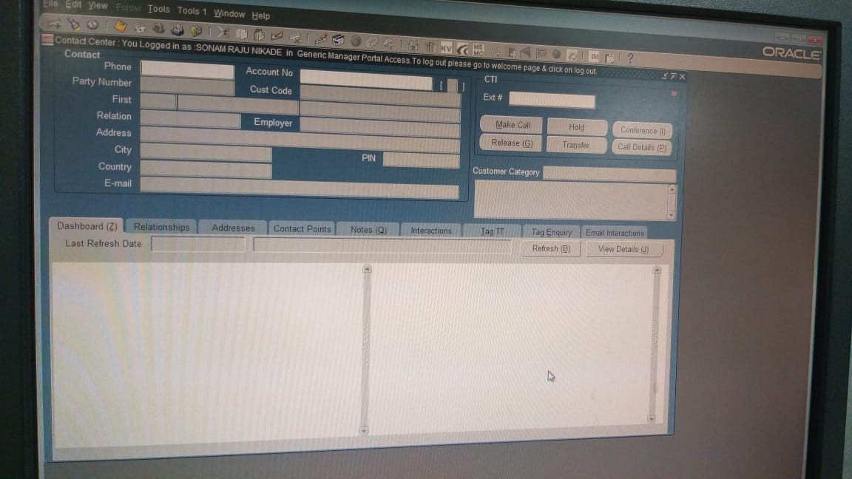

* **Different tabs of CRM:**

1. **Dashboard:**

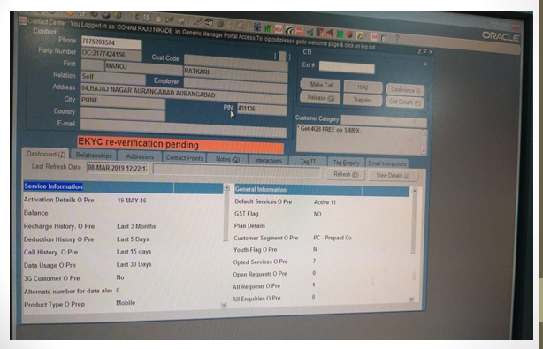

* Here all service and general information related to customer is displayed.

A**. Scenarios**

* Verify that Operator is able to click on Dashboard tab.
* Verify that Operator is able to seen the service information and general information.
* Verify that Operator is able to see last refresh date and time in box.
* Verify that Operator is able to click on refresh button.
* Verify that Operator is able to click on view details button.
* Verify that Operator is able to scroll down and scroll up under service information.
* Verify that Operator is able to scroll down and scroll up under general information

B. **Testing Performed**

* Sanity Testing
* Functional Testing
* Behavioural coverage
* Error handling coverage.
* Backend coverage
* Usability testing
* Regression Testing

1. **Relationships:**

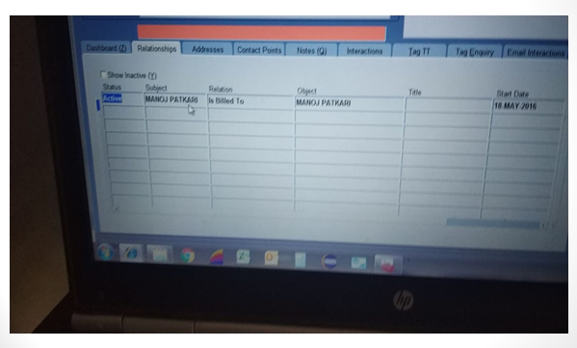

It consists of the customer details, if any other number is connected with the same customer. Billing details like to whom the bill is sent to etc. when the service started, all these details are available here.

A.)**Scenarios→**

* Verify Operator is able to click on relationships tab
* Verify the show inactive checkbox is operating as expected
* Verify data in grid is populated correctly

B) **Types of testing:**

* Sanity Testing
* Functional Testing
* Behavioural coverage
* Error handling coverage.
* Backend coverage
* Usability testing
* Regression Testing

1. **Addresses:**

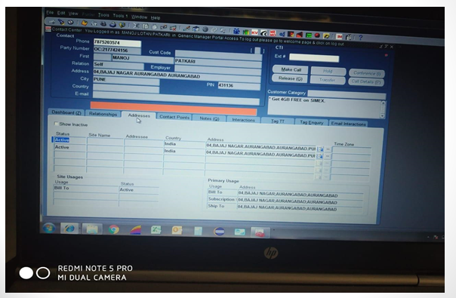

Here the active addresses of customer are available, on which address the bill should be sent, on which address the customer subscriptions are added each detail related to address about the customer is available here.

1. **Scenarios**

* Verify User can click on Address tab
* Verify the functionality of show inactive checkbox
* Verify the status is rightly displayed
* Verify a new address can be added and old address is marked as inactive
* If new address is added, verify the primary usage is changed accordingly
* Verify new address is saved in database correctly

1. **Testings**

* Sanity testing
* Functional Testing
* Behavioural coverage
* Error handling coverage.
* Backend coverage
* Usability testing
* Regression Testing

1. **Contact points:**

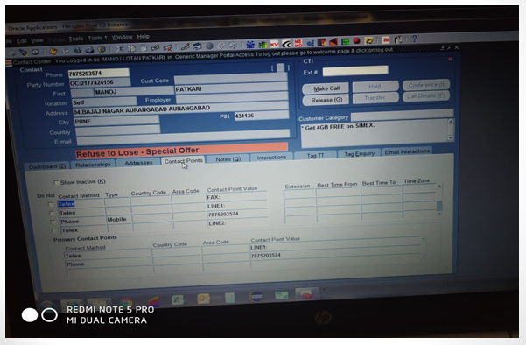

In this tab different contact points that is different ways of contacting customer are mentioned.

1. **Scenarios**

* Verify contact points tab is clickable
* Verify the functionality of show inactive checkbox
* Verify the functionality of Do Not checkbox
* Verify data in primary contact fields table

1. **Testings performed**

* Sanity testing
* Functional Testing
* Behavioural coverage
* Error handling coverage
* Usability testing
* Database testing
* Regression Testing

1. **Notes**

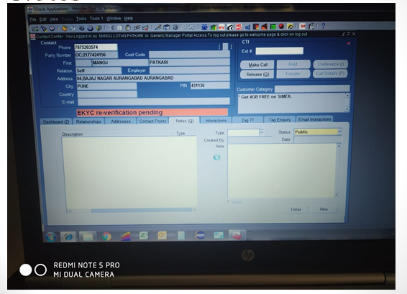

In this tab the description and notes of customer request can be added.

1. **Scenarios:**

* Verify type dropdown is working fine
* Verify Status can be selected as Public/private
* Verify created by and date is auto populated
* Verify User can write in Notes text field
* Verify User can save a new note
* When new note is saved it is reflected in description and Type section
* Verify newly added note is reflected in database.
* **Please explain about your project.**
* Currently I am working on a telecom domain project specifically under BSS (Business Support System) domain.
* As we know there are multiple charges added in every bill like one time charge, rental charge, value added service charge etc. and there are multiple ways of billing like pre-pay billing, post-pay billing, convergent billing etc.
* We have multiple like billions of users using the service and each and every customer may have different requirements so keeping a track of all these usages manually can be a tedious and error prone task.
* To manage the usage in proper way we have developed a CRM according to our customer requirements which is a platform where we can see all the details of each and every customer on a single place.
* To fetch the details of customer in CRM we are currently making use of the mobile number as it is unique for every customer.
* #Note: If the interviewer is more interested you can go ahead and explain about your functionalities of CRM.
* **What are the technical challenges you faced so far?**

When I had joined this project, while the required software installations I was requiring the admin rights which taken 7-8 days to fulfill the request and till then I was not able to proceed with the work and at the end when I was ready with all installations I had to perform multiple tasks within very less time span.

There was a phase in my project when the application was not much stable, the development was in full fledge so the testing was. And there we used to find multiple defects in the day but it was not possible for the dev team to resolve them all at once, and due to the open defects there were many cascading defects occurring and we had to test the application again and again.

**Project** **#2**

**Project Name : Interworks Cloud MSP And Billing Service**

**Client : interworks.cloud, Greece**

**Domain : Telecom**

**Description:**

The interworks. Cloud platform is enabling CSPs, MSPs, and ISVs to grow their ecosystems and automate their cloud distribution processes. It is an end-to-end platform that allows Cloud Service Providers to create cloud service marketplaces for their customers and resellers, as well as automate ordering, billing, and support processes. With more than 15 active integrations and open APIs, our customers can connect their existing business applications and streamline their workflows. The interworks. Cloud platform provides you with everything you need to successfully manage your workflow.

**CSP-Communication service providers**

**MSP-Managed Service Providers.**

**ISV-** **Independent Software Vendor**

